Dissertation dev log
Week 20:
Current Goals for Full Dissertation session:
- Research question made more precise and naturalistic
- Workplan make clearer
- Specification for computing artefact that integrates societal, user, and business needs, demonstrating impact, usability and values to stakeholders
- Design rational, usage guidance, maintainability and architecture overview are provided
- Statistics addendum
- Artefact testing
- Critical addendum
Completed:
- Abstract
- Results and analysis section
- Discussions and conclusion
- Analyse data
- Gather data
- A way to interact with the fragmented mesh
- A working Voronoi fracture in 2D for demonstration
- Working Voronoi fracture in 3D
- Comprehensive background done, covering triangulation, fracturing methods used in games, Graphics API’s, Performance of Graphics API’s, Point sampling, and Voronoi Clipping.
- Clearly stated research question
- Clear, feasible hypothesis, that is well scoped.
- An introduction that provides clear context for the project, and explains the need for the research, including positive impacts and who benefits. It should also highlight the motivation for the project.
- Professional, ethical, sustainable, legal, and social review carried out.
- A plan for security and privacy concerns has been written, and data is well managed.
- A methodology for how the project is going to be researched, and how its going to be evaluated
- A working way of profiling the results of the prototype
- Voronoi clipping implemented

- A Critical Review of current technology is completed, that highlights where the gap in research is, and the how this project fills it.
- Project is ethically robust
- Project plan with gantt chard
- Profiling results that are easily replicated and are well documented.
- Fracture implemented in both OpenGL and Vulkan
- Readme that highlights development roadmap
- OpenGL integrated into bridge system
- An implementation in GLSL, for performance comparison

Bugs
- OpenGL buffering of data has to be done In a specific order, i.e., declare positions, then buffer it, then declare textures, and then buffe them
- Mesh needs tetrahedralization, which means constrained Delaunay triangulation

Development notes:
Data has been gather, analysed, and discussed in my paper. This is a first draft, but overall allowed be to come to some surprising conclusions, such as both my hypothesis’s being false, and OpenGL performing better than Vulkan on a 5070, but Vulkan performing better on a laptop 4080. A challenge was that it was difficult to defend my results, with the 5070 being so different. I have a feeling this is due to the computer it was tested on but cannot prove it.
Images: 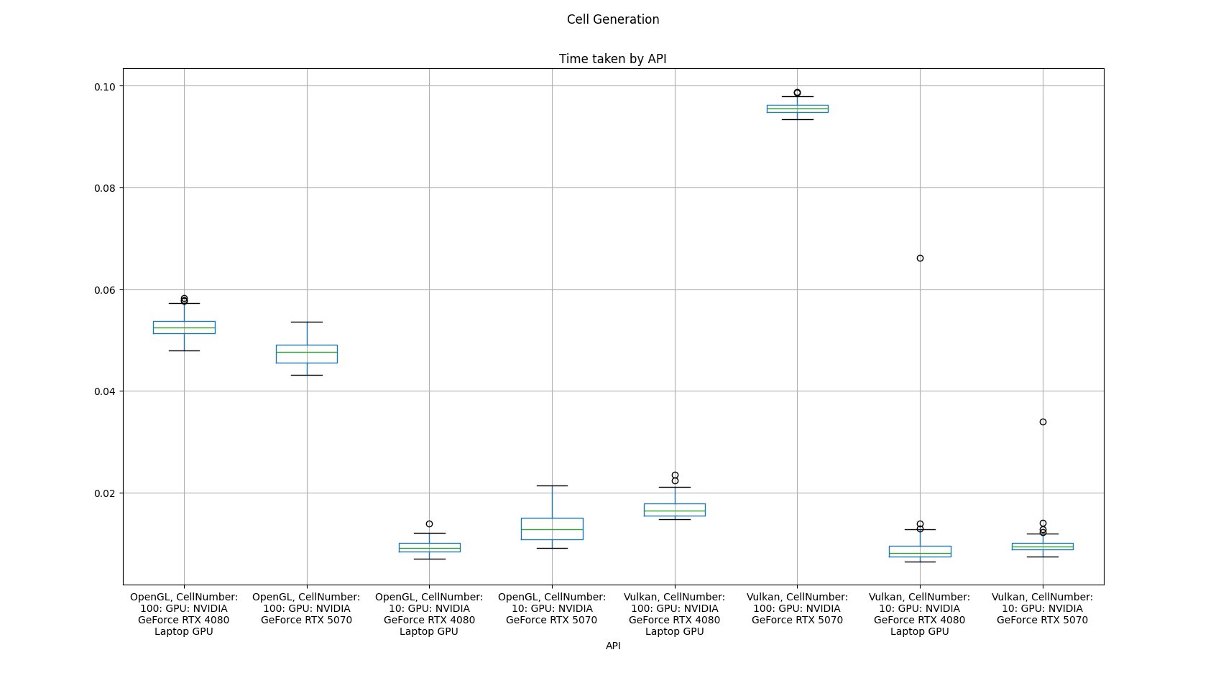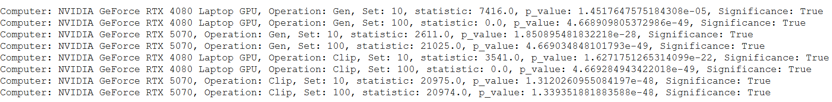

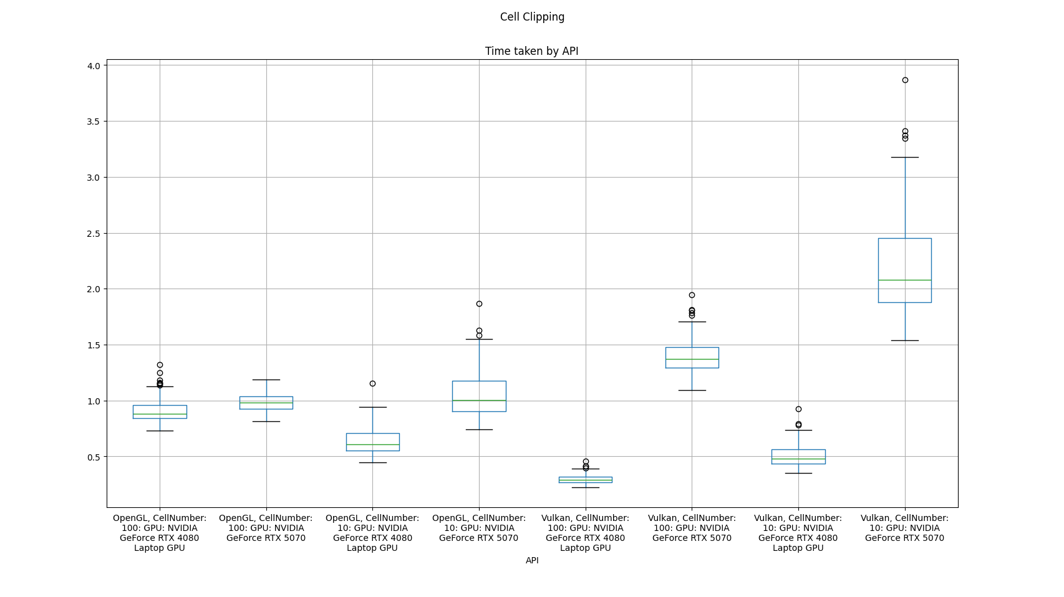
References:

